Using the SMART Ad-Hoc Security Master Import (ASI)

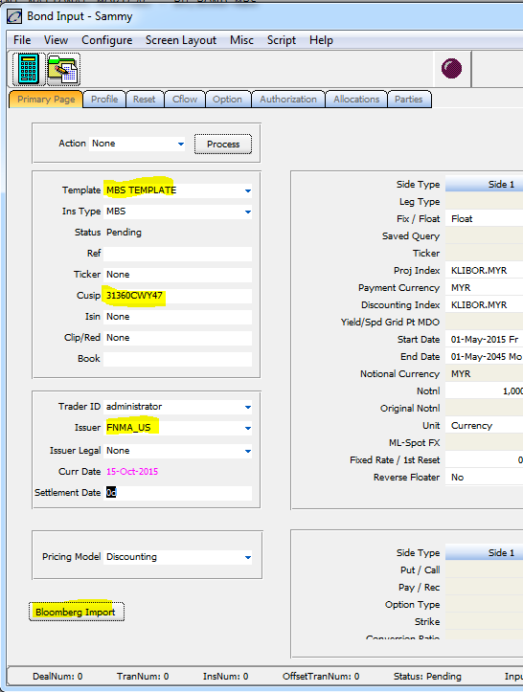

Bond Input Window (Primary Page Tab)

In section 3.1.3.3, a plugin was installed and attached to a button on an instrument input form. For the button to function, a specific convention must be followed. A new instrument should be selected or a currently displayed instrument’s fields should be cleared. A template must be selected, a CUSIP or ISIN entered, and an Issuer selected.

On clicking the button, the plugin queries the current instrument import form and retrieves the values from the following fields for use as input:

Template name

Cusip or Isin

Issuer

The template name must correspond to a mapping that uses this template.

Mapping Definition Tab

The script uses the above as input. Load the mapping associated with the template and create an instrument based on the fields of the mapping.